Watson Et Al 2020

* In Scotland, heat accounts for 51% of energy demand (Scottish Government, 2018).
* The MVS is host to two potentially significant geothermal resources
  + insulated groundwater in flooded abandoned mine-workings
  + hot sedimentary aquifers within the Lower Carboniferous Kinnesswood Formation and Upper Devonian Knox Pulpit Formation and lateral equivalents (Browne et al. 1985; 1987; Gillespie et al. 2013). HSA setting of the Lower Carboniferous and Upper Devonian sandstones of the MVS were identified as a potential target resource (Browne et al., 1985, 1987; Downing and Gray, 1986; Brereton et al., 1988). Despite concluding that a likely exploitable temperature of 60 °C could be accessed at c. 2 km depth, the drilling risks and associated expenditure meant that the resource remained untapped.
* A lack of consideration of palaeoclimate corrections has thus far resulted in a significant underestimation of the heat flow, and therefore, the geothermal potential across the UK
* objective of this work has been to unravel the effect of palaeoclimate on existing geothermal data in the Glasgow area, revealing an estimation of its true geothermal potential

Despite the long tradition of coal exploration, and minor oil and gas exploration in the MVS, there is a scarcity of deep onshore boreholes in central Scotland. The hydraulic properties of both the flooded abandoned mineworkings and the deeper hot sedimentary aquifer remain poorly understood (Ó Dochartaigh et al., 2018), and uncertainty still remains regarding the likely temperature accessible in either potential geothermal resource setting however recent efforts have begun to investigate this (Watson et al., 2019).

Previous studies of the potential geothermal resource in the UK neglected corrections to heat flow measurements for the cooling effects from periods of lower temperatures during the Pleistocene. That past climate change can perturb subsurface temperature gradients, from which heat flow is calculated, in boreholes of several hundred metres depth (e.g. Benfield, 1939; Anderson, 1940; Crain, 1968; Jessop, 1971; Beck, 1977), especially in the UK where there is large temperature differential between modern times and past ice ages (effect of Gulf Stream). Recent work on correcting measurements in boreholes across the UK, accounting for warming since the last glaciation, resulted in a positive correction to heat flow, up to 20 mW/m2 (Westaway and Younger 2013). This would indicate that a lack of consideration of palaeoclimate has resulted in an underestimate of heat flow, and therefore, geothermal potential across the UK (Westaway and Younger, 2013; Busby et al., 2015; Beamish and Busby, 2016; Westaway and Younger, 2016).

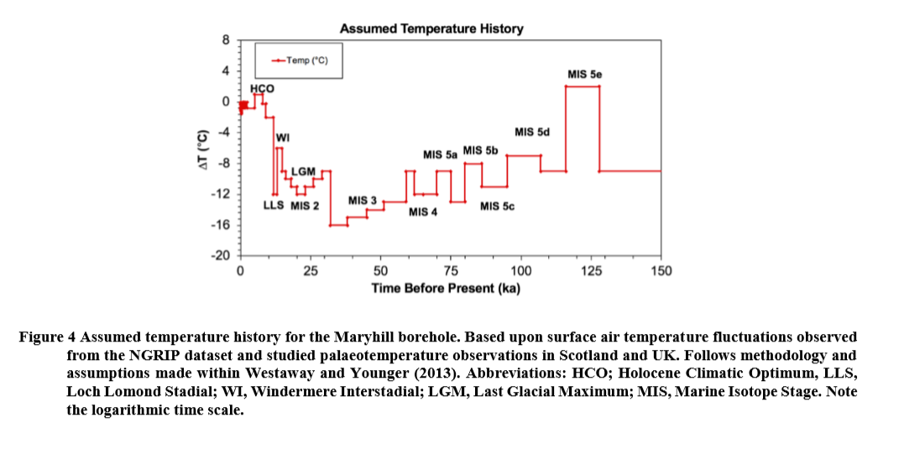 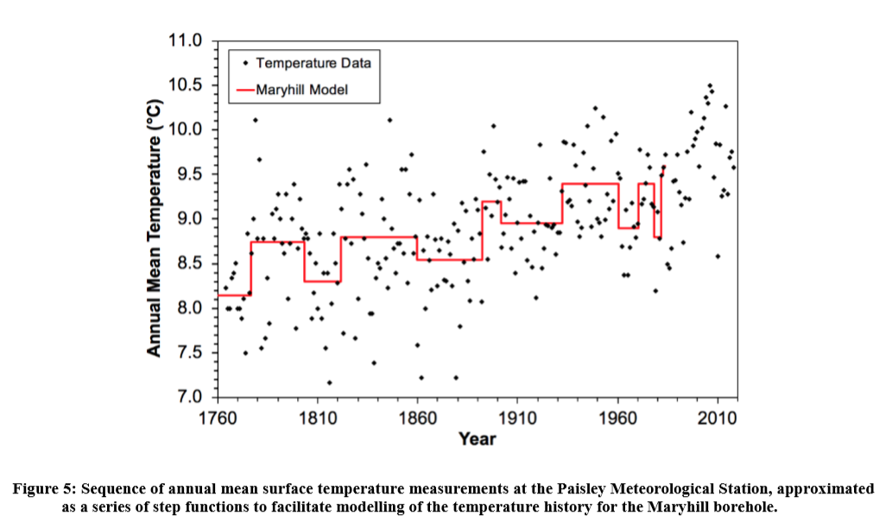

As an input to the modelling software, accounting for the percentage of each lithology present in the borehole, the harmonic mean thermal conductivity and thermal diffusivity were determined across the depth range within the borehole over which the raw heat flow was calculated. Mean values of thermal conductivity for each lithology in the borehole were determined either from BGS thermal conductivity measurements in the borehole or from literature. Similarly, appropriate values of density and specific heat capacity for each lithology were obtained from the literature, and values of thermal diffusivity then calculated. This analysis results in harmonic means of 1.79 W m-1 K-1 for thermal conductivity and 0.809 mm2 s-1 for thermal diffusivity.

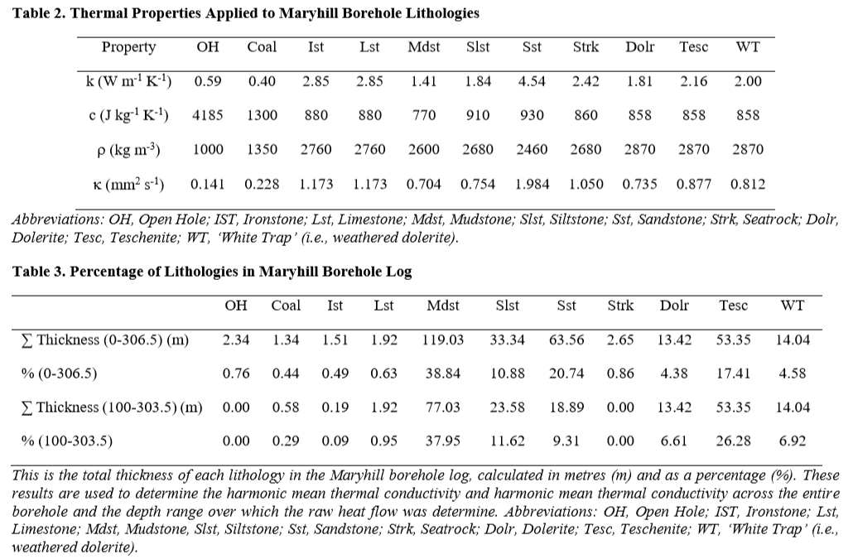

Applying a correction for palaeoclimate to the Maryhill borehole dataset increases the estimated heat flow from 63 to c. 80 mW m-2 for the Maryhill borehole. Using the harmonic mean thermal conductivity, the uncorrected and corrected geothermal gradients are 35 and 44.5 °C km-1. The corrected geothermal gradient can be extrapolated to depth to provide a preliminary estimate of the temperature in the potential hot sedimentary aquifer beneath Glasgow, using the harmonic mean thermal conductivity and thermal diffusivity of the Lower Carboniferous and Upper Devonian stratigraphy between the base of the Maryhill borehole and the hot sedimentary aquifer. The depth to the base of the Upper Devonian aquifer at the site is estimated to be 1880 m. The harmonic mean thermal conductivity and thermal diffusivity of the stratigraphy between the base of the borehole and the base of the Upper Devonian is determined to be 2.55 W m-1 °C -1 and 1.085 mm2 s-1. Assuming a surface temperature of 9.55 °C, the corrected geothermal gradient was extrapolated to give a temperature at 1880 m is c. 83 °C with a geothermal gradient of 38.94 °C km-1.